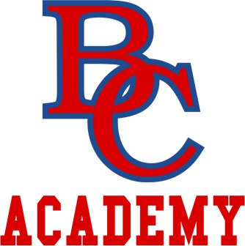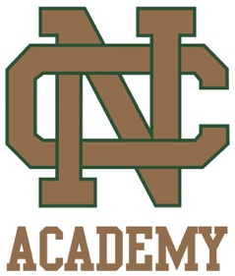

301 N. Farragut 5055 Corey Road
Bay City, MI 48708 Mancelona, MI 49659
989-414-8254 231-584-2080

The Board Meeting scheduled for Tuesday, February 12, 2019, has been CANCELLED. Business will be taken up at the March 12, 2019 Board Meeting

